SAFELY RE-OPENING BUILDINGS
a FACT SHEET
for Building Owners/Operators

prepared by the  Canadian  Water and Wastewater  Association  May 2020 | 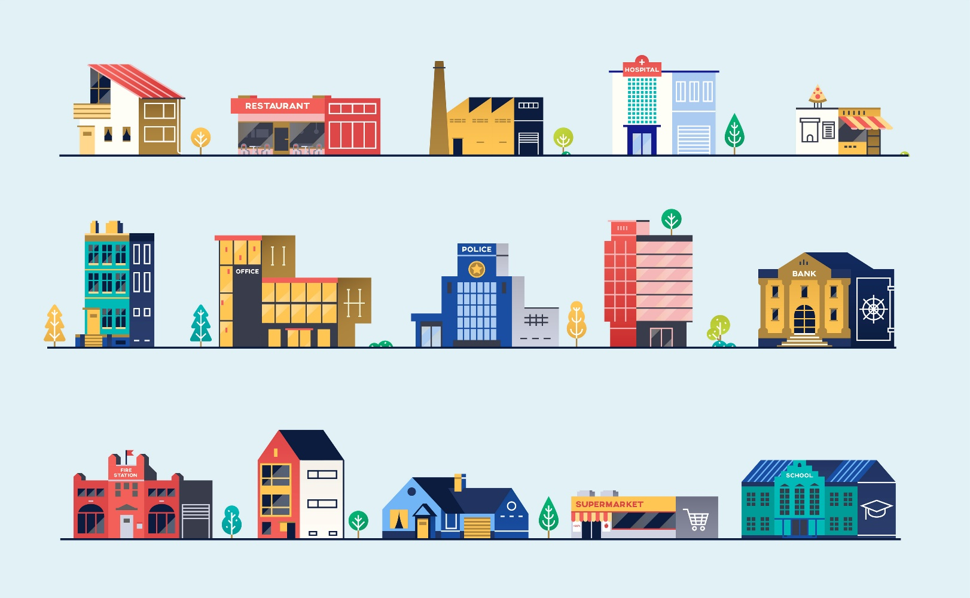
Additional resources will be posted to www.cwwa.ca
as they become available.

KEY CONTACT: | Robert Haller  Executive Director  Canadian Water and Wastewater Association  www.cwwa.ca | rhaller@cwwa.ca

The Issue

When buildings are closed or on low occupancy for any prolonged period, water in the building becomes stagnant and can pose serious health risks. Harmful microbiological and chemical contaminants can grow or leach into water supply.

The effect of such stagnation will vary between each building based on factors such as length of the shutdown, size of the building, number of occupants, complexity of the system, integrity of the plumbing, and maintenance performed during the shutdown.

Responsibility

While municipal utilities are responsible to get clean, safe drinking water to each property, it is the responsibility of each property owner to ensure it maintains the safety of that water within their building.

Canadian utilities, provincial/federal ministries and local public health authorities are here to support you and provide advice. This fact sheet is intended to identify the major concerns, to list issues that should be considered and to provide reference information and more detailed guidance. These considerations should be addressed before allowing tenants and visitors to re-occupy any building that has been closed for a prolonged period.

COVID-19
National response to the COVID-19 crisis has forced the prolonged closure or reduced occupancy of many buildings. This includes, offices, retail outlets, restaurants, hotels, factories and more. This also includes many institutions such as schools, libraries and community centres. Now, as Canadian provinces and territories begin to lift restrictions, and communities prepare to re-open public spaces, we need all building owners and operators to be aware of issues that could threaten the safety of the water and sewer services in their building.

What are the possible concerns?

In general, when a building is not in use and the building water system is not actively maintained, the water becomes stagnant within the pipes, equipment, and any storage tanks. The disinfectant residual decays and disappears, hot water systems can become cooler and cold water systems can become warm. This can lead to the following:

Microbial growth | Stagnant water provides an opportunity for harmful pathogens such as Legionella (especially L. pneumophila), Mycobacteria (e.g. Mycobacterium avium complex), Pseudomonas aeruginosa, Acanthamoeba, that can cause infections in persons through ingestion, inhalation and/or absorption into the skin.
Lead & Copper | When water sits for any period in a pipe or fixture made from lead or copper, the water can absorb Lead that has leached from the pipe. Lead consumption is not safe and maximum acceptable concentrations (MAC) have been set in the Canada Drinking Water Guidelines.
Disinfection  by-products | Water utilities use disinfectants to minimize microbial proliferation in water distribution systems. These disinfectants can slowly react with other components of the water to form harmful disinfection by-products. These can build up in stagnant water.

Wear PPE | The following pages will outline steps that should be taken to prepare a building for occupation. While conducting these steps, staff should wear appropriate personal protective equipment such as gloves, masks (N95 is recommended) and eye protection.

Maintenance & Mitigation During a Shutdown:

During any period of shutdown or low occupancy, building owners/operators can mitigate the concerns identified above by undertaking the following:
 | Make a Plan | - Before your start, develop a basic Flushing Plan:  - Make a map or sketch of your entire system that identifies zones and all equipment, pumps, tanks, valves, etc.  - identify all points of potential cross-contamination  - identify your pipe materials and know how they react  - make a list of all outlets and fixtures (taps/showers/fountains) and be sure to include food units (ice & coffee makers)  - consider water pressure throughout system and where you might have stagnation in areas of potential low pressure  - keep a detailed log of all maintenance conducted, tests conducted and all results  - moving forward, you want to develop a full Water Management Plan with protocols and schedules
 | Flushing | - Routinely flush the system:  - Regular flushing at all outlets replaces stagnant water within the system with fresher, treated water to minimize the risk of microbial growth in plumbing  - Weekly flushing is generally recommended, but site specific flushing guidance should be developed as part of your long term Water Management Plan in line with recommendations from your public health officials  - How the flushing is done will vary based on size, complexity of system, volumes used, internal plumbing and the characteristics of the municipal water supply  - See the recommended flushing process on the Checklist page at the end of this Fact Sheet
 | Disinfecting | - Maintain microbial growth deterrents:  - Maintain disinfectant residual (such as chlorine) throughout the water distribution system by flushing  - Hot water tanks should kept above 60˚C to ensure hot water is kept above 50˚C throughout the system

Re-opening a Building:

Recommissioning | Recommissioning refers to activities performed in re-opening a building’s water distribution system after extended closure. The aim is to restore the water quality to baseline conditions. This differs from activities that are performed for brand new buildings or when new additions are introduced to the building’s plumbing.  The extent of recommissioning efforts depends on the preventative maintenance steps taken during the shutdown or low occupancy.
Flushing | Flushing. This is a more rigorous and extended flushing than regular maintenance intended to not just replace the stagnant water but also dislodge sediment and biofilms.  - See the recommended flushing process on the CHECKLIST page at the end of this Fact Sheet
Cleaning | Cleaning. Again, more rigorous cleaning of fixtures such as taps, fountains, showers and connected food units, as well as any key components such as mixing valves and filters.
Shock chlorination | Shock Chlorination. In some cases, you may need to consider disinfecting the system by circulating water with high concentrations of chlorine. But this need only be considered for complex systems with storage tanks or remote zones, buildings serving very vulnerable populations or buildings with a history of microbial issues.  - Shocking should be conducted by a water professional  - You need to know your various pipe materials (lead vs PVC) and understand how they react with various chemicals  - Warning - shock disinfection can potentially damage components such as devices, and filters. Manufacturers should be contacted before undertaking a shock disinfection

Other Considerations:

System Integrity | System integrity. This may be a good opportunity to check the entire system for any leaks, pressurization issues and dead zones. Check any on-site disinfection systems and the temperature controls on hot water supply equipment.  Double-check for any possible points of cross contamination and ensure protection devices like backflow controls are in place and tested.
Pipe material | When developing site-specific recommissioning protocols, you need to consider your specific pieces of equipment and the internal plumbing and pipe material and its compatibility with temperatures and (or) chemicals to be used.
Costs | Associated costs of recommissioning may include:  - increased volume of water required for flushing and the equivalent wastewater generated  - retaining the services of a plumbing/water expert or engineering services  - testing equipment, testing procedures and/or professional testing services
Drains & Sewers | Wastewater systems that haven’t been used for some time need to be flushed to ensure solids and sediment are washed away. Floor drains and pea traps are a concern as the water in them may have evaporated over the shutdown causing odour issues. You want to ensure that all drains and traps are refilled.

Where can you get more detailed guidance:

Resources

Public Health Authority | We would first recommend you check with your local public health authority for the applicable provincial regulations and guidelines.
Municipality | Assistance and direction may be sought from your water utility and/or Chief Building Inspector.
Professional Associations | Further resources are available from professional associations such as:  Canadian Water and Wastewater Association (CWWA)  www.cwwa.ca  American Water Works Association (AWWA)  www.awwa.org  Walkerton Clean Water Centre (WCWC)  https://training.wcwc.ca/en/resources/  Canadian Institute of Plumbing and Heating (CIPH)  www.ciph.com

Applicable Guidelines and Documents
Health Canada
Guidelines for Canadian drinking water quality summary table. https://www.canada.ca/content/dam/hc-sc/migration/hc-sc/ewh-semt/alt_formats/pdf/pubs/water-eau/sum_guide-res_recom/sum_guide-res_recom-eng.pdf
Guidance for Providing Safe Drinking Water in Areas of Federal Jurisdiction V2
https://www.canada.ca/en/health-canada/services/publications/healthy-living/guidance-providing-safe-drinking-water-areas-federal-jurisdiction-version-2.html

Environmental Science Policy & Research Institute (ESPRI)
Building Water Quality and Coronavirus: Flushing Guidance for Periods of Low or No Use.
(https://esprinstitute.org/wp-content/uploads/2020/04/FINAL_Coronavirus-Building-Flushing-Guidance-20200403-rev-1.pdf)

American Water Works Association (AWWA)
Coronavirus (COVID-19) Resources and Tools
(https://www.awwa.org/Resources-Tools/Resource-Topics/Coronavirus)

Public Works and Government Services Canada
MD 15161-2013. Control of Legionella in Mechanical Systems, Chapter 6 – Domestic Water.
https://www.tpsgc-pwgsc.gc.ca/biens-property/documents/legionella-eng.pdf

Proctor CR, Rhoads WJ, Keane T, Salehi M, Hamilton K, Pieper KJ, Cwiertny DM, Prévost M, Whelton AJ.
Considerations for Large Building Water Quality after Extended Stagnation. https://www.iapmo.org/media/23699/considerations-for-large-building-water-quality-after-extended-stagnation.pdf

Rhoads W, Whelton A, Proctor C.
Building Water System COVID-19 Guidance Document Evaluation Tool. https://engineering.purdue.edu/PlumbingSafety/covid19/Guidance-Evaluation-Tool.pdf

ANSI/ASHRAE Standard 188-2018.
Legionellosis: Risk Management for Building Water Systems https://www.ashrae.org/technical-resources/bookstore/ansi-ashrae-standard-188-2018-legionellosis-risk-management-for-building-water-systems

U.S. Center for Disease Control (CDC)
Toolkit: Developing a Water Management Program to Reduce Legionella Growth and Spread in Buildings. https://www.cdc.gov/legionella/wmp/toolkit/index.html

Ontario Municipal Water Association (OMWA)
Webinar – Exiting One Crisis and Mitigating Another https://www.omwa.org/water3/may-1-webinar-slides-and-audio-available/

Purdue University. Frequently Asked Questions- Building Water Safety in Response to COVID-19.
https://engineering.purdue.edu/PlumbingSafety/covid19/resources/faq-building-water-safety

CHECKLIST
Re-Opening Buildings - Building Owners/Operators

- Before you start - Map or sketch your entire water system
- Identify zones and include all treatment equipment, pumps, valves, tanks, etc.
- list all outlets/fixtures such as taps, fountains, showers, etc.
- be sure to include any connected food units like ice or coffee makers

- Flush your entire system
- start where the water enters the building and work from closest to furthest, closest zone to furthest zone, closest outlet to furthest outlet
- flushing requirements vary but run the water until the water maintains a constant cold temperature and the disinfectant (like chlorine) is detected
- this should be a rigorous flush so you want to open taps fully (remove the aerator filter or shower head) but be aware this could cause greater spray and aerosols
- staff should wear appropriate PPE such as gloves, mask (N95 is recommended), and eye cover while flushing

- Hot Water
- Flush your cold water system first then your hot water system
- Hot water tanks should be kept above 60˚C to ensure a temperature over 50˚C throughout the system. Be sure to flush the tank fully to replace all of its water. You may consider draining the tank, but be cautious as this could stir up sedimentation or cause syphoning concerns
- Then flush the hot water system from closest to furthest from the tank

- Cleaning
- If possible, clean, disinfect and rinse all outlets, screens etc.

- Shocking your system
- Shock chlorination may only need to be considered if you have a large system with remote branches, storage tanks, or you still detect issues after flushing, if you serve vulnerable populations or have a history of pathogen problems
- Such system shocking should be conducted by a water treatment professional

- Testing
- For smaller buildings, after flushing, you should be able to feel a consistent cold temperature and even detect disinfectant (such as chlorine by smell)
- For larger buildings and any building serving vulnerable populations, professional testing is highly recommended
- Testing for disinfectant residual - simple equipment and/or testing services are available from local water treatment companies, plumbers and pool professionals
- Testing for microbial pathogens – for complex systems, buildings serving vulnerable populations, or any with a history of contaminations (like Legionella) – these issues are often related to water in HVAC systems. Your local health unit should be contacted for assistance.

THIS IS A SIMPLE CHECKLIST – REFER TO THE RESOURCE LINKS FOR DETAILED GUIDANCE

